China's persistent growth: exchange rate policy

and capital flow management

Lorenzo T. Donato
Ricardo Chaves Lima
Abstract
This article discusses how China has managed to maintain relative stability over several years of rapid growth, which can also be attributed to the country´s high level of exports. However, with the high inflow of foreign capital, China´s current and capital accounts become surpluses, which contributed to an appreciation pressure on the yuan. Considering that, it was shown how China has aligned the management of the money stock in its economy with the exchange rate policy adopted. If on the one hand China wanted to maintain the fixed exchange rate, while maintaining currency depreciation and competitiveness in international trade, on the other hand having the fixed exchange rate undermined the country's monetary independence, which would be detrimental to sterilizing the effects of the large capital inflow in the country. Therefore, it was possible to demonstrate the role of capital flow management through monetary and exchange rate strategies to stabilize China´s macroeconomy and sustain its growth.

Resumo
O artigo discute como a China conseguiu manter uma relativa estabilidade ao longo de vários anos de rápido crescimento econômico, que pode também ser atribuído ao alto nível de exportação do país. No entanto, com uma grande entrada de capital estrangeiro no país, a conta corrente a conta de capital da China tornaram-se superavitárias, o que contribuído para uma forte pressão de valorização do yuan. Considerando estes fatos, foi demonstrado como a China alinhou a gestão do estoque monetário em sua economia com a política cambial adotada. Se, por um lado, a China desejava manter a taxa de câmbio fixa, garantindo a desvalorização da moeda e a competitividade no comercio internacional, por outro lado, ter a taxa de câmbio fixa reduzia a independência monetária do país, o que seria prejudicial à esterilização dos efeitos das grandes entradas de capital no país. Portanto, foi possível demonstrar o papel da gestão do fluxo de capital por meio de estratégias monetárias e cambiais para estabilizar a macroeconomia da China e sustentar seu crescimento.

Artigo recebido em 11/11/2019 e aceito em 23/12/2019.

INTRODUCTION
In the mid-1980s, China began to call the world's attention by its ease of attracting foreign capital. Between 2000 and 2010, China maintained an average annual growth rate of approximately 10%, with a large amount of capital inflow simultaneously. In spite of that, the country's exchange rate and inflation remained relatively stable.
To analyze this context, we use a money stocks model (money supply), relating it to the monetary base and its multiplier. Through the management of endogenous variables to this model, as the data in this study will show, China was able to mitigate the negative effects of the large capital inflow in the country. But to this end, it was also necessary to adopt a strategy related to the country's exchange rate, giving relative monetary independence, so that it was possible to sterilize the effect of the large inflow of foreign capital.
To study the case of China development – as a lot of other impressive growth cases around the world – the economics literature is indispensable. One big concern of the rapidly developing countries that receive a large amount of foreign capital is related with domestic prices and exchange rate stability. Especially in the case of China, to maintain domestics prices, wages and the exchange rate stable was critical to allow high growth rate to continue for more years. Chinese competitiveness in international trade is extremely linked to the value of its exchange rate. In case of appreciation of the yuan (Chinese currency), the export price would be more expensive, as would the labor force in the country itself.
Given these facts, it's necessary understand the economics of how Central Banks can work to maintain money supply stability in the economy when there is a significant increase in foreign reserve. It is also very important to understand how exchange rate policy is linked to the country's monetary capacity to mitigate the effects of large capital inflows.

THEORIC MODEL
The money stocks (or money supply) can be described as: (Mishkin ed.2016, 367-387)
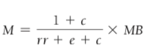
Where,
M = Money supply (Money stocks)
MB = Monetary base
c = currency ratio
e = excess reserve ratio
rr = reserve requirement ratio
As the parameters "e" and "c" depends on the behavior of the agents (commercial banks and
money bearers respectively), the only instrument that PBOC - People's Bank of China (China's Central Bank) have to act directly on the base multiplier is through "rr", which is the reserve requirement ratio that banks must keep in reserve, determined by the Central Bank.
Besides that, Central Bank can act in money stock availability directly through open markets operations affecting the monetary base. For example, if the central bank issues bonds and makes open market sales, there will be pressure to reduce the stock of money in the economy.
For countries with a huge foreign exchange reserve accumulation, such as China, it is very important to determine how to manage growing reserves. One common approach is to limit the forward reserve accumulation adopting a currency police which will prevent appreciative forces on the currency, maintaining the trade competitiveness and the macroeconomic stability, such as price level. As economic theory points out, countries that export more receive a higher demand for their currency and, as a consequence, there is a force for the appreciation of this currency. That statement would be true in cases of countries with a purely free floating regime. In China´s case, and many others developing countries, the currency is not completely free to float. Actually, it is usual when currencies are pegged. So, when a country has a fixed exchange rate regime, it may represent competitiveness advantage, since even with the very positive trade balance and consequent large capital inflows, the exchange rate remains stable. Even so, the completely fixed exchange rate can be very dangerous, as it seriously compromises the country's monetary independence.
As shown in Figure 1, expansionary monetary police wouldn't have any affect in a country with a fixed exchange rate and with a perfect capital mobility (Mundell 1963, 475-485). In an IS-LM-BP model, like figure 1 represents, an expansionary monetary would move LM1 to LM2. After that, the economy would be in a balance of payment deficits. Since the exchange rate is fixed, represented by BP curve, a government interevent would be required. To bring LM2 back to LM1, and so the initial exchange rate, the government would buy domestic currency and sell foreign currency. In the final equilibrium, it can be seen that, according to the Mundel-Fleming model, monetary policy loses its effect in a country with a fixed exchange rate and capital mobility.

Figure 01 – Expansionary monetary policy under a fixed exchange rate and capital mobility
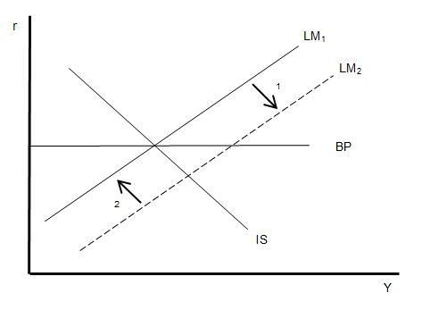
Of course, in reality, it's difficult to find countries where the exchange rate is completely pegged and have a perfect capital mobility simultaneously. However, that does not eliminate the fact that when countries in the real-world fix their exchange rate, domestic monetary police may be compromised and so the management of large capital inflows.

CHANGIN PATTERNS OF CAPITAL FLOW
Empirical studies have shown that export-led and investment-led growth strategies were relevant to explain Chinese economic development (Herrerias and Orts, 2010). But looking mainly to the export side, there is 2 main reasons to explain China's success in meeting a high demand for international trade: cheap qualified skilled labor and relatively undervalued currency, which make it easy for developed countries to buy from China. It is important, however, to understand China's early development phase during the late seventies, which allowed China to achieve the well-known status of major exporter.
First of all, it's important to show how FDI (Foreign Direct Investment), current account and, consequently, capital account levels were poor in late 70s until the beginning of twentieth first century. The main reason for those results was the capital control police adopted; China wasn't a globalized country as it is today. So, the first progressive police launched to reverse this situation was a miniliberalization of capital inflow, but only in a form of FDI inflows. Indirect forms of capital inflow should be avoided. This strategy was developed taking Latin America financial crises as reference. The countries of south and central Americas have experienced a large capital flight, because great amount of foreign capital inflow was in the form of hot money. So, with the FDI authorization in 1979, China was building its way to economic modernization (Françoise Lemoine 2000).
To incentive FDI inflows at this point, China launched two main strategies:
- Special economic zones (Yongding Yu 2008): Based on Deng Xiaoping's instructions, 4 special economic zones (SEZs) were stablished aiming to attract FDI inflow. These areas had a tax and business incentive to foreign companies and investors.
- Export promotion and Import protection: China utilized the old-fashioned economic strategy of industry protection. The export industries were insulated form indirect effects of protection, as the exporting sector was allowed to import goods in a duty-free regime.
The capital inflow, mainly in form of FDI, rose significantly until 1997, when Asia met one of its biggest financial crises. But, before that, from 1982 to 1997, China's FDI inflow grew around of 10,187.67% - from U$430 Billion (1982) to U$44.237 Trillion (1997) - as shown in Figure 02.
Figure 2 – FDI inflow in china 1982-1997 (U$ billion)
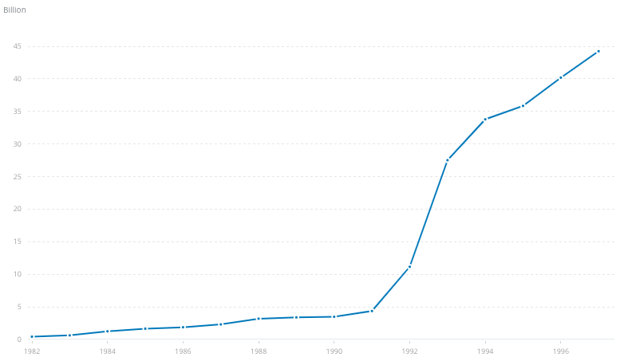
Source: data.worldbank.org
After the significative growth of capital inflow, some provisional measures got in a little bit different shape. The tariff restriction to imported goods was lowered, rules of FDI inflow were eased and news sectors were opened to receive FDI. All that capital account liberalization features were responsible to make China the second biggest recipient to FDI in the 90s, only losing to United States. That situation would become even more favorable, when China joined WTO (World Trade Organization) in 2001. In 2002, one year after join the WTO, China surpassed the US and became the biggest aim from FDI reaching U$53.074 Billion.
Hence, as the capital inflow grew in accelerated rhythm, the twin accounts surplus (capital and current) rose significantly as well. As a result of the twin account surplus, there were a pressure to appreciation on yuan (RMB exchange rate), which was clearly not favorable to China's growth strategy. It is possible to see the fast growing of both accounts in Figure 3, especially when China joined WTO.
Figure 3 – China's current account and capital account 2003 – 2010 (U$ billion)
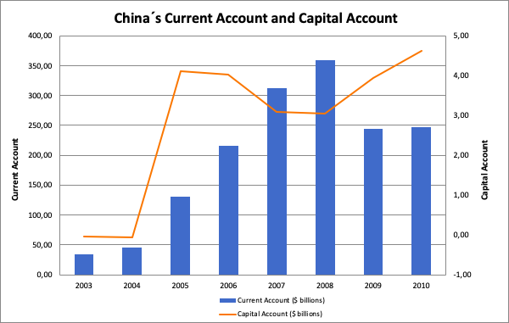 Note: All the expectations of appreciation on RMB, provides big changes in China's management of cross-border capital flow aiming to maintain the trade competitiveness and macroeconomics stability.

CAPITAL FLOW MANAGEMENT TO MAINTAIN MACROECONOMICS AND RMB EXCHANGE RATE STABILITY
Mainly after China's entrance in WTO (2001), the debate about RMB's appreciation came up as an urgent agenda. There was a real concern about a new deflationary effect, problem which have been solved few years before. Besides that, another economics unfavorable situation happened because of the level of capital inflow.
The economy overheating and exaggerated level of capital inflow could be reflected in some indicators and facts:
- Rising prices on the equity index;
- Constantly high growth rate of housing prices;
- Real state bubbles (2003 e 2004);
- Excess liquidity.
One of the biggest PBOC's (People's Bank of China) concerns was about the effects of capital inflows on the monetary base and, consequently, on the money supply. Control the stock of money available is essential to maintain prices level stability. In front of that fact, PBOC needed to find ways to control money stocks in economy, even with the large inflow of foreign capital. As money supply literature indicates (Mishkin ed.2016, 367-387) the 2 main forms to control the money stocks adopted by PBOC were: i) Open market operations ii) changes in required reserve rate to commercial banks.
Through open market operations, the PBOC was capable to manage the monetary base and sterilize the effect of capital inflow. Until the end of 2002, the balance of central banks bills was around 0. But, after that, along with growing twin account surplus, the balance of central bank bills increases incessantly until 3rd quarter of 2007, when the balance was marking around 4 trillion RMB, as can be seen in Figure 4.
Figure 4 – PBOC bills balance 2003 – 2007 (U$ billion)
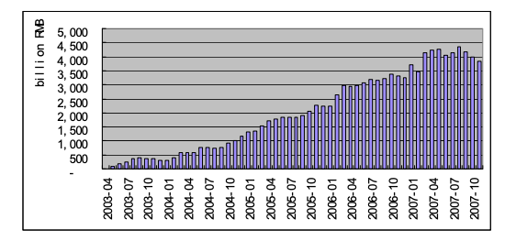Source: chinabond.com.cn

Another way to sterilize the effect of a large capital inflow it's through controlling the reserve requirement rate. Once the PBOC define the reserve requirement rate, all commercial banks in China must have to maintain part of the deposits in the form of compulsory reserves. As effect of that, there will be less money circulating in people's hands. Another way to see it is looking to the base multiplier previously presented. When PBOC increase the required reserve rate (rr), ceteris paribus, the base multiplier is decreased. Then, it's possible to conclude that controlling the "rr" it's an efficient way to provides stability on money stocks. That's exactly what have been done in China's case. When capital account and current account surpluses grew drastically, the required reserve rate imposed by PBOC followed the movement, as showed in Figure 5
Figure 5 – Reserve requirement ratio 2000-2012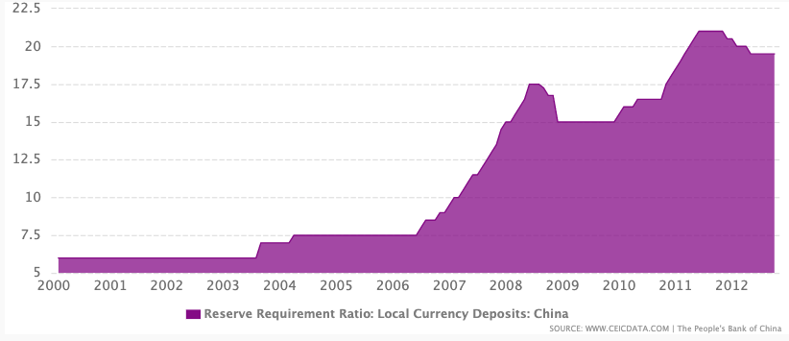
The sheer magnitude of PBOC issuance of bonds made it hard to the market to absolve all these securities. As a result, since mid-2006 the PBOC began to manage the money stocks less on bond issuance then through open market operations, and more on the required reserve rate increases. All those changes were looking to mop up excess liquidity and controlling foreign money aggregates, preventing an accelerated growth of foreign reserves.
But China's concern was not only related to the direct effect of capital inflow on the stock of currency in its economy. The RMB exchange rate should maintain its stability and continue to provide competitive advantage in China's international trade.
From 1997 to 2005, the RMB value was fixed to the US dollar. But, after mid-July 2005, a more flexible regime was launched. After that measure, there was some appreciation of the RMB in respect to the US dollar. That happened because china's need a monetary independence, and countries that have their currencies completely pegged in another currency or fixed, lost control of the domestic money supply (Obstfeld and Rogoff 1995). But why controlling the money supply was so important for China's trade objective? Competitiveness depends on more than the nominal exchange rate, especially when it is pegged in another currency. Inflation, for example, can make a great difference between nominal and real exchange rate. And, how money supply, mainly in long-run, is related to inflation, China's need to manage it to maintain its competitiveness and so its high growth rates.
With the more flexible regime, as said earlier, RMB-dollar rate reached 6.8 in 2008, when the government decided to peg the yuan rigidly to dollar again, just going back to a more flexible regime a few years later. All RMB-dollar rate (exchange rate) can be analyzed in Figure 6.
Figure 6 – Dollar/RMB rate (exchange rate) 2001-20013
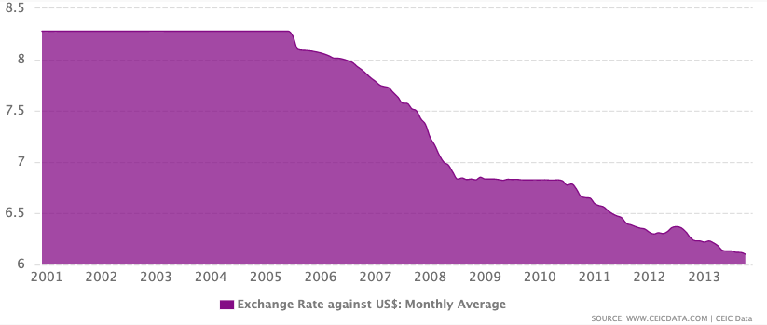
Even when China's relaxed its exchange rate policy, it couldn't be totally free floating. It happened because if the exchange rate was flexible, speculation in China's fragile system could bring a lot of instability by its variations. To complete the reasoning then, is important highlight two main parts to Chinese exchange rate policy. The first is the exchange rate protection, a policy developed to maintain the product and employment derivatives of a devalued exchange rate in the export sector. The second part is to maintain a stable exchange rate, avoiding volatility in a fixed but adjustable rate (Corden 2009, F430-F441).
In view of the arguments presented, it is possible to perceive an important role of monetary management aligned with an exchange rate policy for the case of Chinese development. While the fixed exchange rate is beneficial for Chinese competitiveness, this policy may compromise the management of capital inflows into China. Therefore, exchange rate flexibilities have been and are essential for timely monetary adjustments indispensable for the country's economic stability. Another extremely favorable point is related to cross-border capital flow management. By selecting the type of capital that can enter the country and avoiding the inflow of large amounts of speculative capital, it is easier to prevent the undesirable consequences of large capital inflows, as well as to avoid drastic capital flight.
CONCLUSION
China successfully combined exchange rate management, pegging and easing when appropriate, with an effective central bank policy that has managed to act correctly on the monetary base through the buying and selling of securities in open market operations, and on the base multiplier, through the required reserve rate for banks. Thus, the effect of the large inflow of capital was sterilized, not opening up to unfavorable situations of inflationary control and exchange rate appreciation, which would result in a competitive loss in relation to the global market.
But, as we know, even when exchange rate regime was eased, it wasn't even close to a flexible regime. So, the question is: Is China's exchange rate policy sustainable in the long-run? A lot of studies have been dedicating its efforts to study the complexity of Chinas development strategy and its stability. In the presented study we could observe efficient management of the money stock and exchange rate, enabling relatively sustainable growth during the 2000s. However, as China has been growing and growth rates are declining, we are unable to say, only with the arguments and data demonstrated in this article, if in the coming years an aligned exchange rate strategy and monetary policy will be sufficient to stabilize the China's.
REFERENCES
Corden, W. Max. 2009. China's exchange rate policy, its current account surplus and the global imbalances. Chapter 6 - China's New Place in a World in Crises.
Gligck, R., Hutchison, M. 2008. Navigating the Trilemma: Capital Flows and Monetary Policy in China. Working Paper 2008-32.
Goldstein, M., Lardy, N. 2008. Debating China's Exchange Rate Policy. Peterson Institute for International Economy.
Lemoine, F. 2000. FDI and the Opening Up of China's Economy. CEPII – Document de travail n° 00-11.
Ma, G., McCauley, R. 2008. Efficacy of China's Capital Controls: Evidence from Price and Flow Data. Pacific Economic Review, 2008, vol. 13, issue 1, 104-123.
Mishkin, F. 2016. The Economics of Money, Banking and Financial Markets – 11th edition. Chapter 14 – The Money Supply Process.
Obstfeld, M., Rogoff, K. 1995. The Mirage of Fixed Exchange Rates. Journal of Economic Perspectives - Volume 9, Number 4 - Pages 73–96.
Yu, Yongding. 2008. Managing Capital Flows: The Case of the People’s Republic of China. ADBI Discussion Paper 96. Tokyo: Asian Development Bank Institute.

Universidade Federal de Pernambuco. Departamento de Economia.
Universidade Federal de Pernambuco. Departamento de Economia.

